
STUDENT CASE STUDY EXECUTION REPORT
Department | FED
Subject | DSA-2
Academic Year | I-III semester(2025-26)
Faculty Name | Sukanya
Student Name | Devaji Rashmika
Roll Number | 2520090152
Branch | CSIT
Course Outcome

Case Study Topic: University Lecture-Hall Scheduling using Greedy Activity Selection Algorithm
Work Done Summary:
In this case study, we implemented the Greedy Activity Selection algorithm to schedule the maximum number of non-overlapping lecture-hall events.
The university received 8 booking requests with different start and end times, and only one lecture hall was available.
We sorted activities based on earliest finish time and selected compatible activities greedily.
We also analysed the weighted activity-selection variant using Dynamic Programming and studied interval graph colouring to determine the minimum number of halls required.
Implementation Details:
- Represented all lecture requests as activities with start and end times.
- Sorted activities in ascending order of finish time.
- Applied greedy selection:
  - Pick activity if start time ≥ previous selected activity end time.
- Tracked selected and skipped activities step-by-step.
- Implemented weighted activity selection using Dynamic Programming.
- Analysed interval overlap using sweep-line technique to compute minimum hall count.
Result: Screenshots / Output
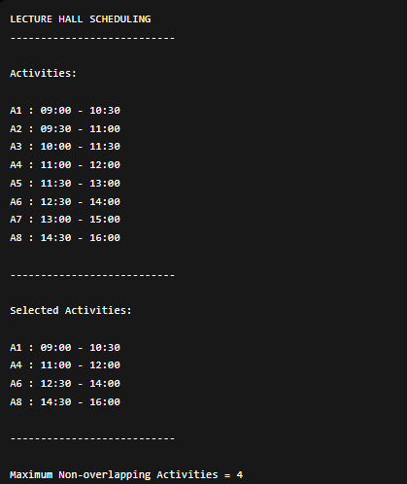
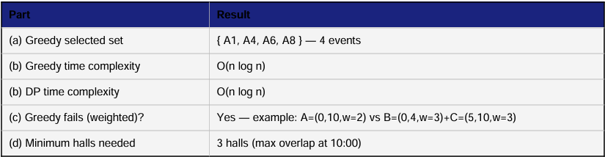

GitHub Link:
Student Signature | Faculty Signature

